**All components of this case study have to be executed in R.**

DATA PREPARATION:

1. **Make a grouped bar chart depicting the hour-wise trip request made at city and airport respectively. You can aggregate the data for all 5 days on the same axis of 24 hours. Each bar should correspond to an hour and pick-up point (city / airport) should be displayed in two colors**.

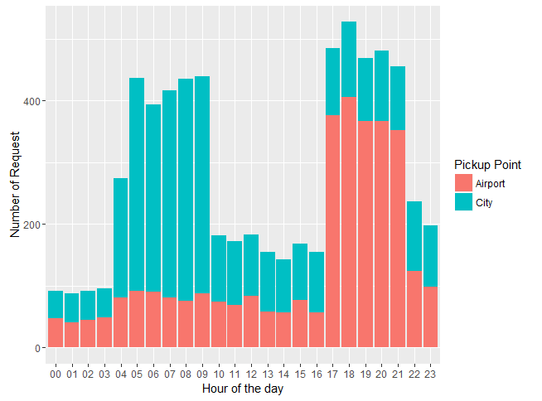

1. **In the bar chart (question 1), you’ll be able to see 5 major time blocks based on the frequency of requests made at the city and airport. You have to now divide the request-time into 5 time-slots described below. Make an additional column “Time_Slot” which takes these 5 categorical values depending on the request time:**
   * Pre_Morning
   * Morning_Rush
   * Day_Time
   * Evening_Rush
   * Late_Night

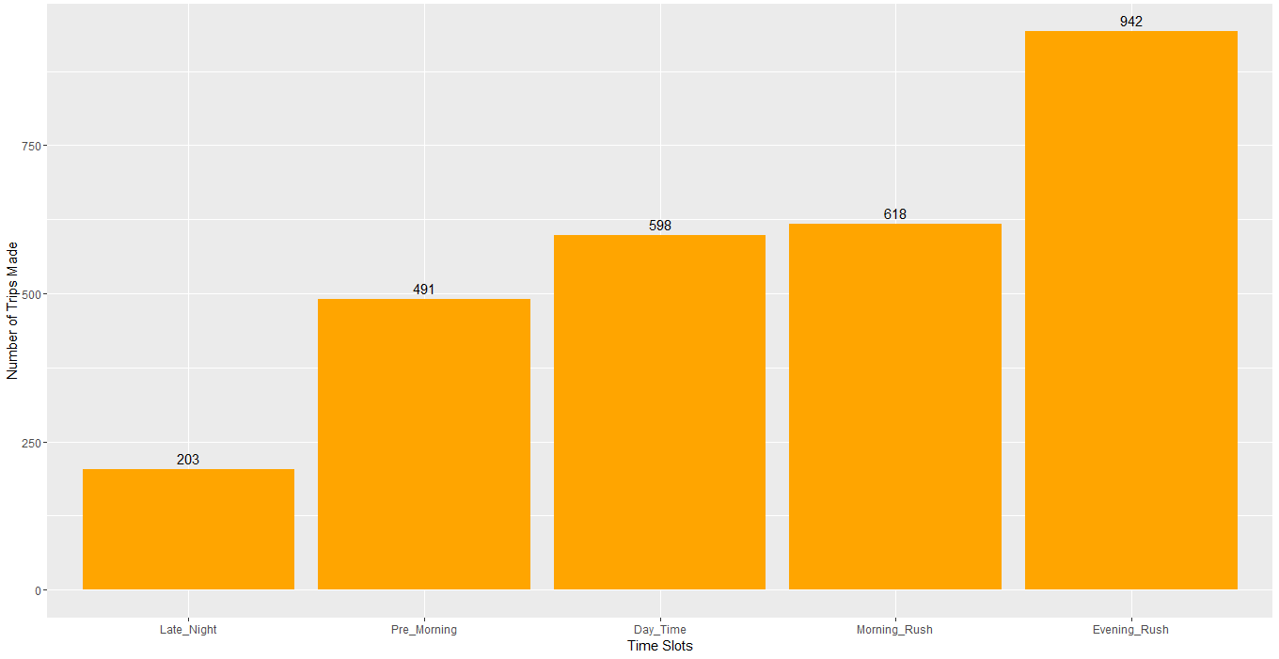

Note: The division of time-slots may not have one right answer.

**Also give the count of the number of trips made during different time slots you have decided**.

* Pre_Morning: 491
* Morning_Rush: 618
* Day_Time:  598
* Evening_Rush:  942
* Late_Night:  203

**PROBLEM IDENTIFICATION:**

1. 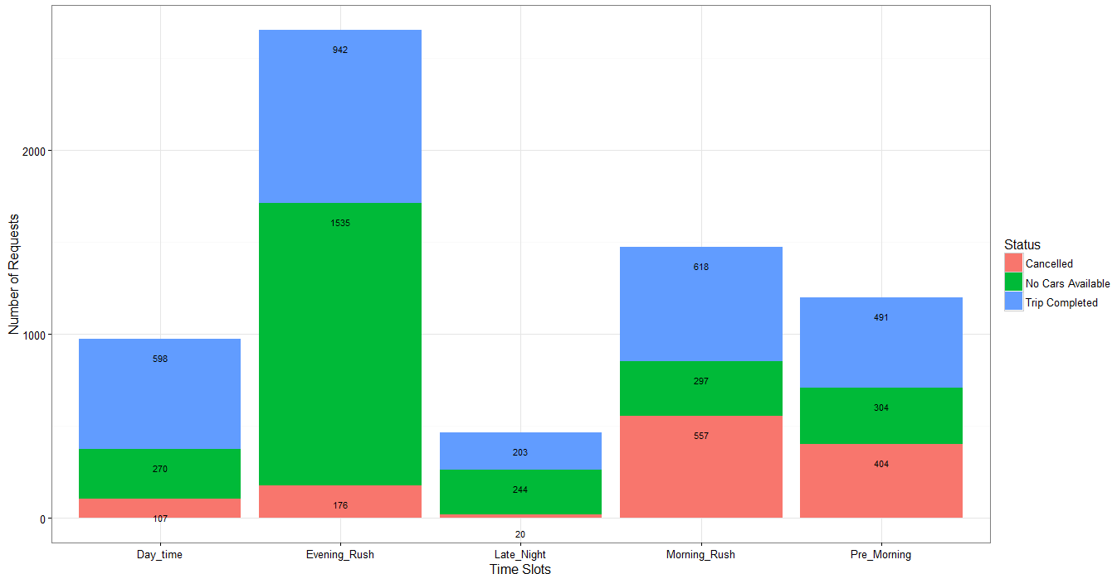 **Make a stacked bar chart where each bar represents a time slot and y axis shows the frequency of requests. Different proportions of bars should represent the completed, cancelled and no cars available out of the total customer requests**.
2. **Visually identify the 2 most pressing problems for Uber, out of the 15 possible scenarios (5 slots * 3 trip status).**
3. **Enter your diagnosis results here:**

* **Problem 1**:  During the Morning Rush hour Most number of trips are cancelled
* **Problem 2:** During Evening Rush Maximum time No cars are available

**Problem 1**:  During the Morning Rush hour Most number of trips are cancelled

1. **For the time slot when problem 1 exists, plot a stacked bar chart to find out if the problem is more severe for pick-up requests made at the airport or the city. As a next step, you have to determine the number of times this issue exists in that time slot**.

Total Number of Cancelled cabs in **Morning Rush Hour:** **557**

Total Number of Cancelled cabs at **City** : **533**

Break-up for hour wise issue in **City**

07 hours <- out of 164 times 159 times

08 hours <- out of 191 times 186 times

09 hours <- out of 178 times 171 times

10 hours <- out of 24 times 17 times

Total Number of Cancelled cabs at **Airport** : **24**

* 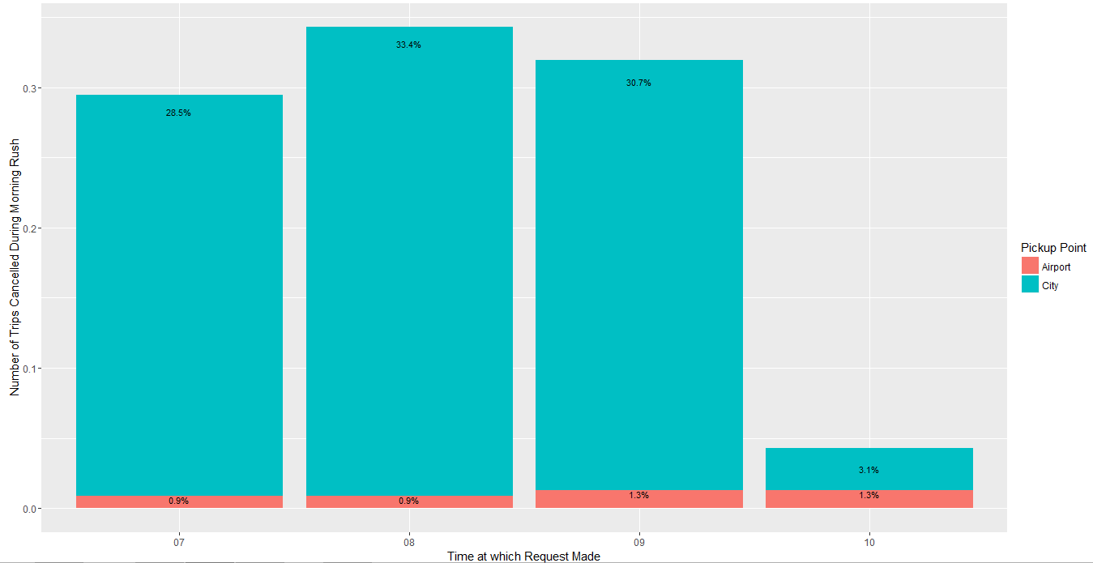**Find the percentage breakup for the total number of issues in this time slot based on the pick-up point.**

* **What is the percentage of total issues at (based on pick-up point)**
* **Airport** : **4.31%**
* **City** : **95.7%**

1. **Now let’s find out the gap between supply and demand. For this case, the demand is the number of trip requests made at the city, whereas the supply is the number of trips completed from city to the airport.**

*No. of trip requests made in city:* ***1153***

*No. of trips completed from city to airport:* ***353***

Assuming that everybody is going in cab for travelling and everybody coming from airport is coming in Cab. In Morning rush hour the cabs are 56.8% cancelled

**3. What do you think is the reason for this issue for the supply demand gap? (Write the answer in less than 100 words).**

The reason for demand and supply gap can be as follows

1. As the time taken from City to airport is more, in which he can do maximum of 2 trips (to-fro from city to airport) while staying in the city he can do more number of trips.
2. During Morning_rush hour the frequency of Morning Flights (7-11) is less and number of passengers from Airport to City would be in turn very less, so either their idle time increases at the airport or they would do a return trip from airport to City without any passenger which is not economically sensible.

**4. What is your recommendation to Uber (Not more than 50 words)?**

1. Uber can introduce some schemes/ benefits to the drivers who are making trips from City to Airport during the Morning Rush hours or introduce special City to Airport cabs
2. Uber can introduce /increase cancellation fees to driver if they cancel the City to Airport request during these hours.

**Problem 2:** During Evening Rush Maximum time No cars are available

1. **For the time slot when problem 2 exists, plot the stacked bar chart to find out if the issue is for pick-up request made at the airport or the city. Just like problem1:**

Total Number of Cancelled cabs in **Morning Rush Hour:** **1535**

Total Number of Cancelled cabs at **City** : **116**

Total Number of Cancelled cabs at **Airport** : **1419**

Break-up for hour wise issue in **Evening Rush Hour at Airport**

17 hour <- Out of 281 times 268 times No cars Available at Airport

18 hour <- Out of 329 times 314 times No cars Available at Airport

19 hour <- Out of 281 times 265 times No cars Available at Airport

20 hour <- Out of 272 times 257 times No cars Available at Airport

21 hour <- Out of 275 times 268 times No cars Available at Airport

22 hour <- Out of 97 times 47 times No cars Available at Airport

* **Find the percentage breakup for issue based on the pick-up point for the time slot in which problem 2 exists**.

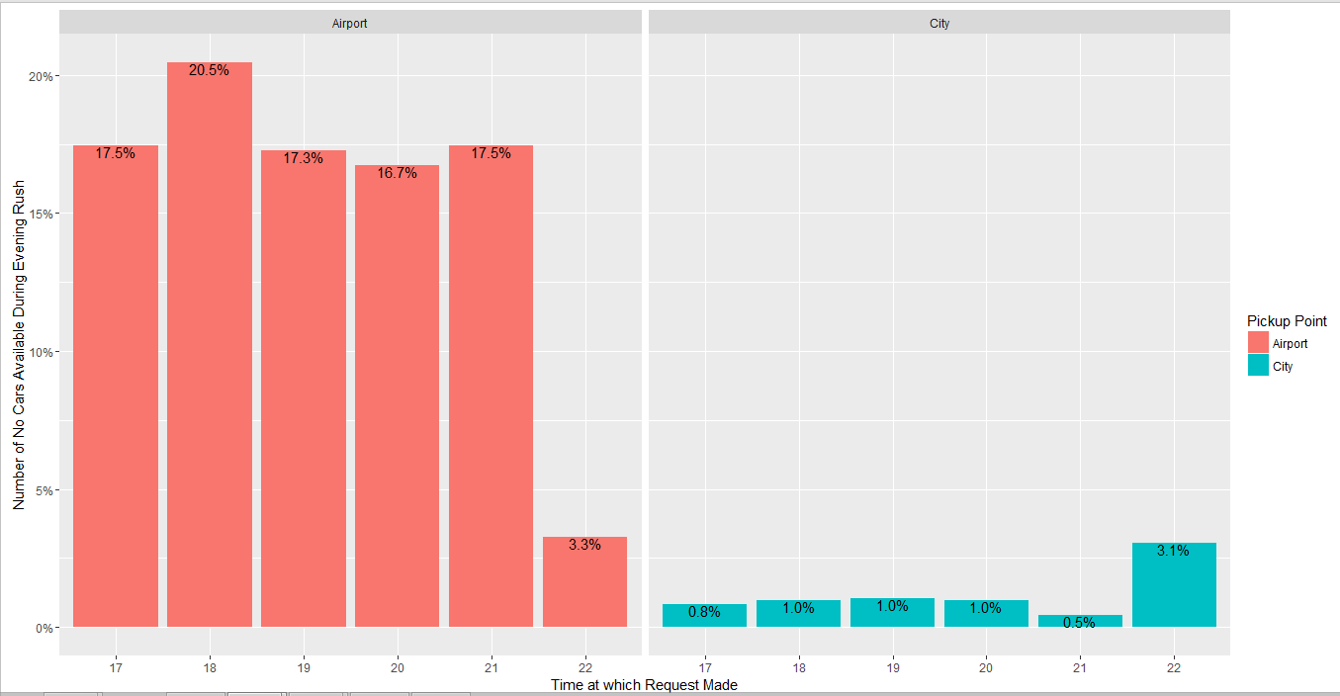

* **What is the percentage of total issues at (based on pick-up point):**
* **Airport** : **92.64%**
* **City**  : **7.4%**

1. **Now let’s find out the gap between supply and demand. For this case, the demand is the number of trip requests made at the airport, whereas the supply is the number of trips completed from airport to the city.**

***No. of trip requests made at the airport****:* ***1990***

***No. of trips completed from airport to the city:******460***

*Around 76.8% times the car is not available in Evening Rush Hour*

1. **What do you think is the reason for this issue for this supply demand gap? (Not more than 100 words)?**
   * + 1. Since , time of travel from Airport to City is high there are not sufficient cabs available during the evening rush hour
       2. From the data for No of Trips Completed from Airport to City we can infer that most of the cabs trips are completed from airport to city during the 3 Time_Slots (Pre_Morning, Morning_Rush, and Day_time, ), so there is no car available in the airport at Evening Rush Hour.
       3. In Evening Rush hour there may be less flights arriving to the airport so the availability of the cab at airport is less.

1. **What is your recommendation to Uber (Not more than 50 words)?**
   * + 1. Uber should increase the fleet of the cabs at the airport during the Evening Rush hour so that cars would be available
       2. Also, introduce some benefits for the trips made from airport to city especially at this point of time.